**Software Engineering Assignment**

**MODULE: 1**

1. **What is software?**

Software: s/w is the language of computer.

* Software is a collection of computer programs and related data that provide the instructions for telling a computer what to do and how to do it.
* Just like human language.
* 3 main groups depending on their use and application

1. System software / operating system.
2. Application s/w
3. Programming language
4. **System s/w or OS:**

* System software refers to a category of computer programs designed to manage a computer’s hardware and application programs.
* is the s/w used by the computer to translate inputs from various sources into a language which a machine can understand.
* These include well-known OSs like **macOS**, **Linux**, **Android**, and **Microsoft Windows**.
* System software runs only when required and loads into main memory as needed.

1. **Application s/w:**

* is the general designation of computer programs for performing user tasks.
* Types of application s/w

1. **Mobile app:**

- Application that run on mobile

- Ex. Instagram, facebook, etc

1. **Desktop app:**

- That run stand-alone in a desktop or laptop computer.

- Ex. Microsoft office suite which includes Word, Excel and PowerPoint.

- Ex. Outlook for email, and firefox, Google Chrome, Mozilla are the web browser.

- Anti-virus is an application and so is the media player.

1. **Web app:**

- That run on a web browser

- ex. google.com, facebook.com, etc

**3. Programming s/w:**

* is the process of designing, writing, testing, debugging, and maintaining the source code of computer programs.
* This s/w is pawritten in a programming language.
* The purpose of programming is to create a program that exhibits a certaindesired behavior.
* Ex. c++, html, java, Simlab, php, Python and Visual basic.

1. **What is Software Engineering?**

* **Software** is a program or set of programs containing instructions that provide desired functionality.
* Engineering is the process of designing and building something that serves a particular purpose and finds a cost-effective solution to problems.

1. Software engineering includes a variety of techniques, tools, and methodologies, including requirements analysis, design, testing, and maintenance.
2. It is a rapidly evolving field, and new tools and technologies are constantly being developed to improve the software development process.
3. By following the principles of software engineering and using the appropriate tools and methodologies, software developers can create high-quality, reliable, and maintainable software that meets the needs of its users.
4. Software Engineering is mainly used for large projects based on software systems rather than single programs or applications.
5. **What is SDLC? Explain each phase of SDLC**

* A software life cycle model (also termed process model) is a pictorial and diagrammatic representation of the software life cycle. A life cycle model represents all the methods required to make a software product transit through its life cycle stages. It also captures the structure in which these methods are to be undertaken.
* A Software Development Life Cycle is essentially a series of steps, or phases, that provide a model for the development and lifecycle management of an application or piece of software.

**SDLC LIFE CYCLE :-**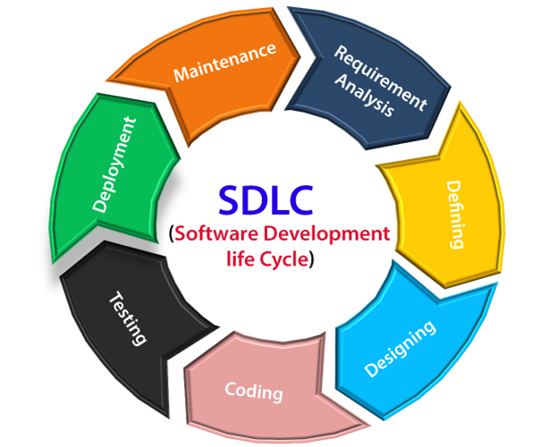

The stages of SDLC are as follows:

**Stage1: Planning and requirement analysis**

Requirement Analysis is the most important and necessary stage in SDLC.

The senior members of the team perform it with inputs from all the stakeholders and domain experts or SMEs in the industry.

Planning for the quality assurance requirements and identifications of the risks associated with the projects is also done at this stage.

**Stage2: Defining Requirements**

Once the requirement analysis is done, the next stage is to certainly represent and document the software requirements and get them accepted from the project stakeholders.

This is accomplished through "SRS"- Software Requirement Specification document which contains all the product requirements to be constructed and developed during the project life cycle.

**Stage3: Designing the Software**

The next phase is about to bring down all the knowledge of requirements, analysis, and design of the software project. This phase is the product of the last two, like inputs from the customer and requirement gathering.

**Stage4: Developing the project**

In this phase of SDLC, the actual development begins, and the programming is built. The implementation of design begins concerning writing code. Developers have to follow the coding guidelines described by their management and programming tools like compilers, interpreters, debuggers, etc. are used to develop and implement the code.

**Stage5: Testing**

After the code is generated, it is tested against the requirements to make sure that the products are solving needs addressed and gathered during the requirements stage.

**Stage6: Deployment**

Once the software is certified, and no bugs or errors are stated, then it is deployed.

Then based on the assessment, the software may be released as it is or with suggested enhancement in the object segment.

After the software is deployed, then its maintenance begins.

1. **What is Flow chart? Create a flowchart to make addition of two numbers**

* Flowchart is a graphical representation of an algorithm. Programmers often use it as a program-planning tool to solve a problem. It makes use of symbols which are connected among them to indicate the flow of information and processing.

**Algorithm of flowchart :-**

* Start
* Declare variable num1, num2, Ans
* Get value from user
* Display sum1+sum2
* Display result

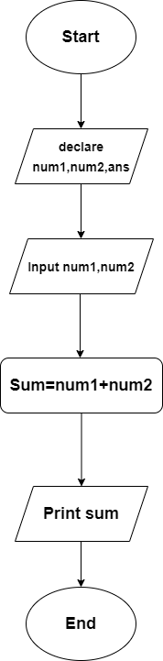

**Flowchart :-**

1. **What is Use case Diagram? Create a use-case on bill payment on Paytm.**

* A use case diagram is a graphical depiction of a user's possible interactions with a system. A use case diagram shows various use cases and different types of users the system has and will often be accompanied by other types of diagrams as well. The use cases are represented by either circles or ellipses.

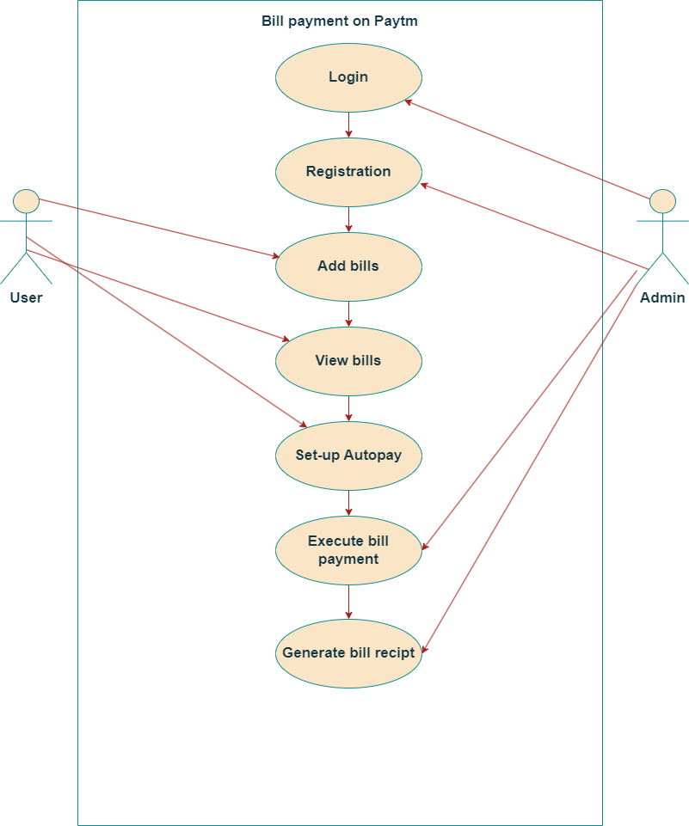

1. **What is DFD? Create a DFD diagram on Flipkart**

* **DFD** is the abbreviation for **Data Flow Diagram**. The flow of data of a system or a process is represented by DFD. It also gives insight into the inputs and outputs of each entity and the process itself. DFD does not have control flow and no loops or decision rules are present.
* Specific operations depending on the type of data can be explained by a flowchart. It is a graphical tool, useful for communicating with users ,managers and other personnel. it is useful for analyzing existing as well as proposed system.

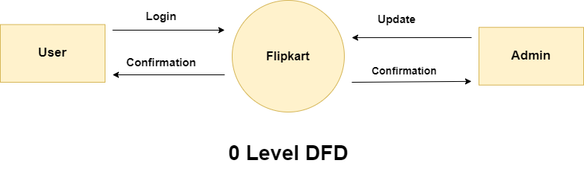

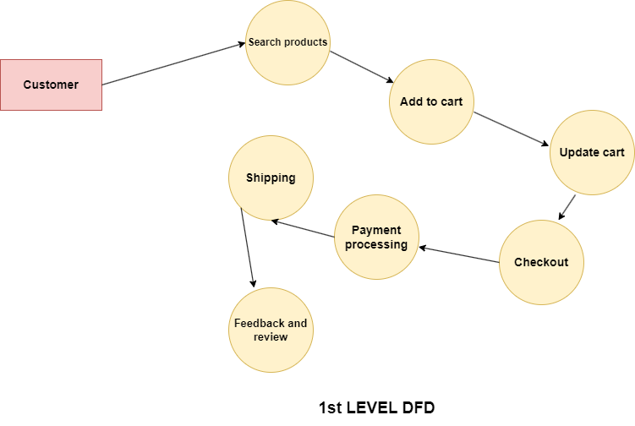

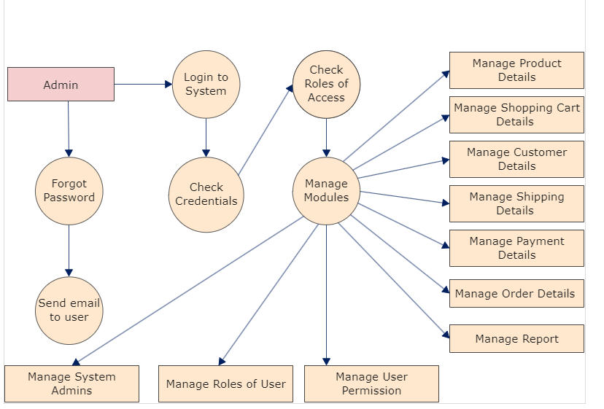

**2nd LEVEL DFD**